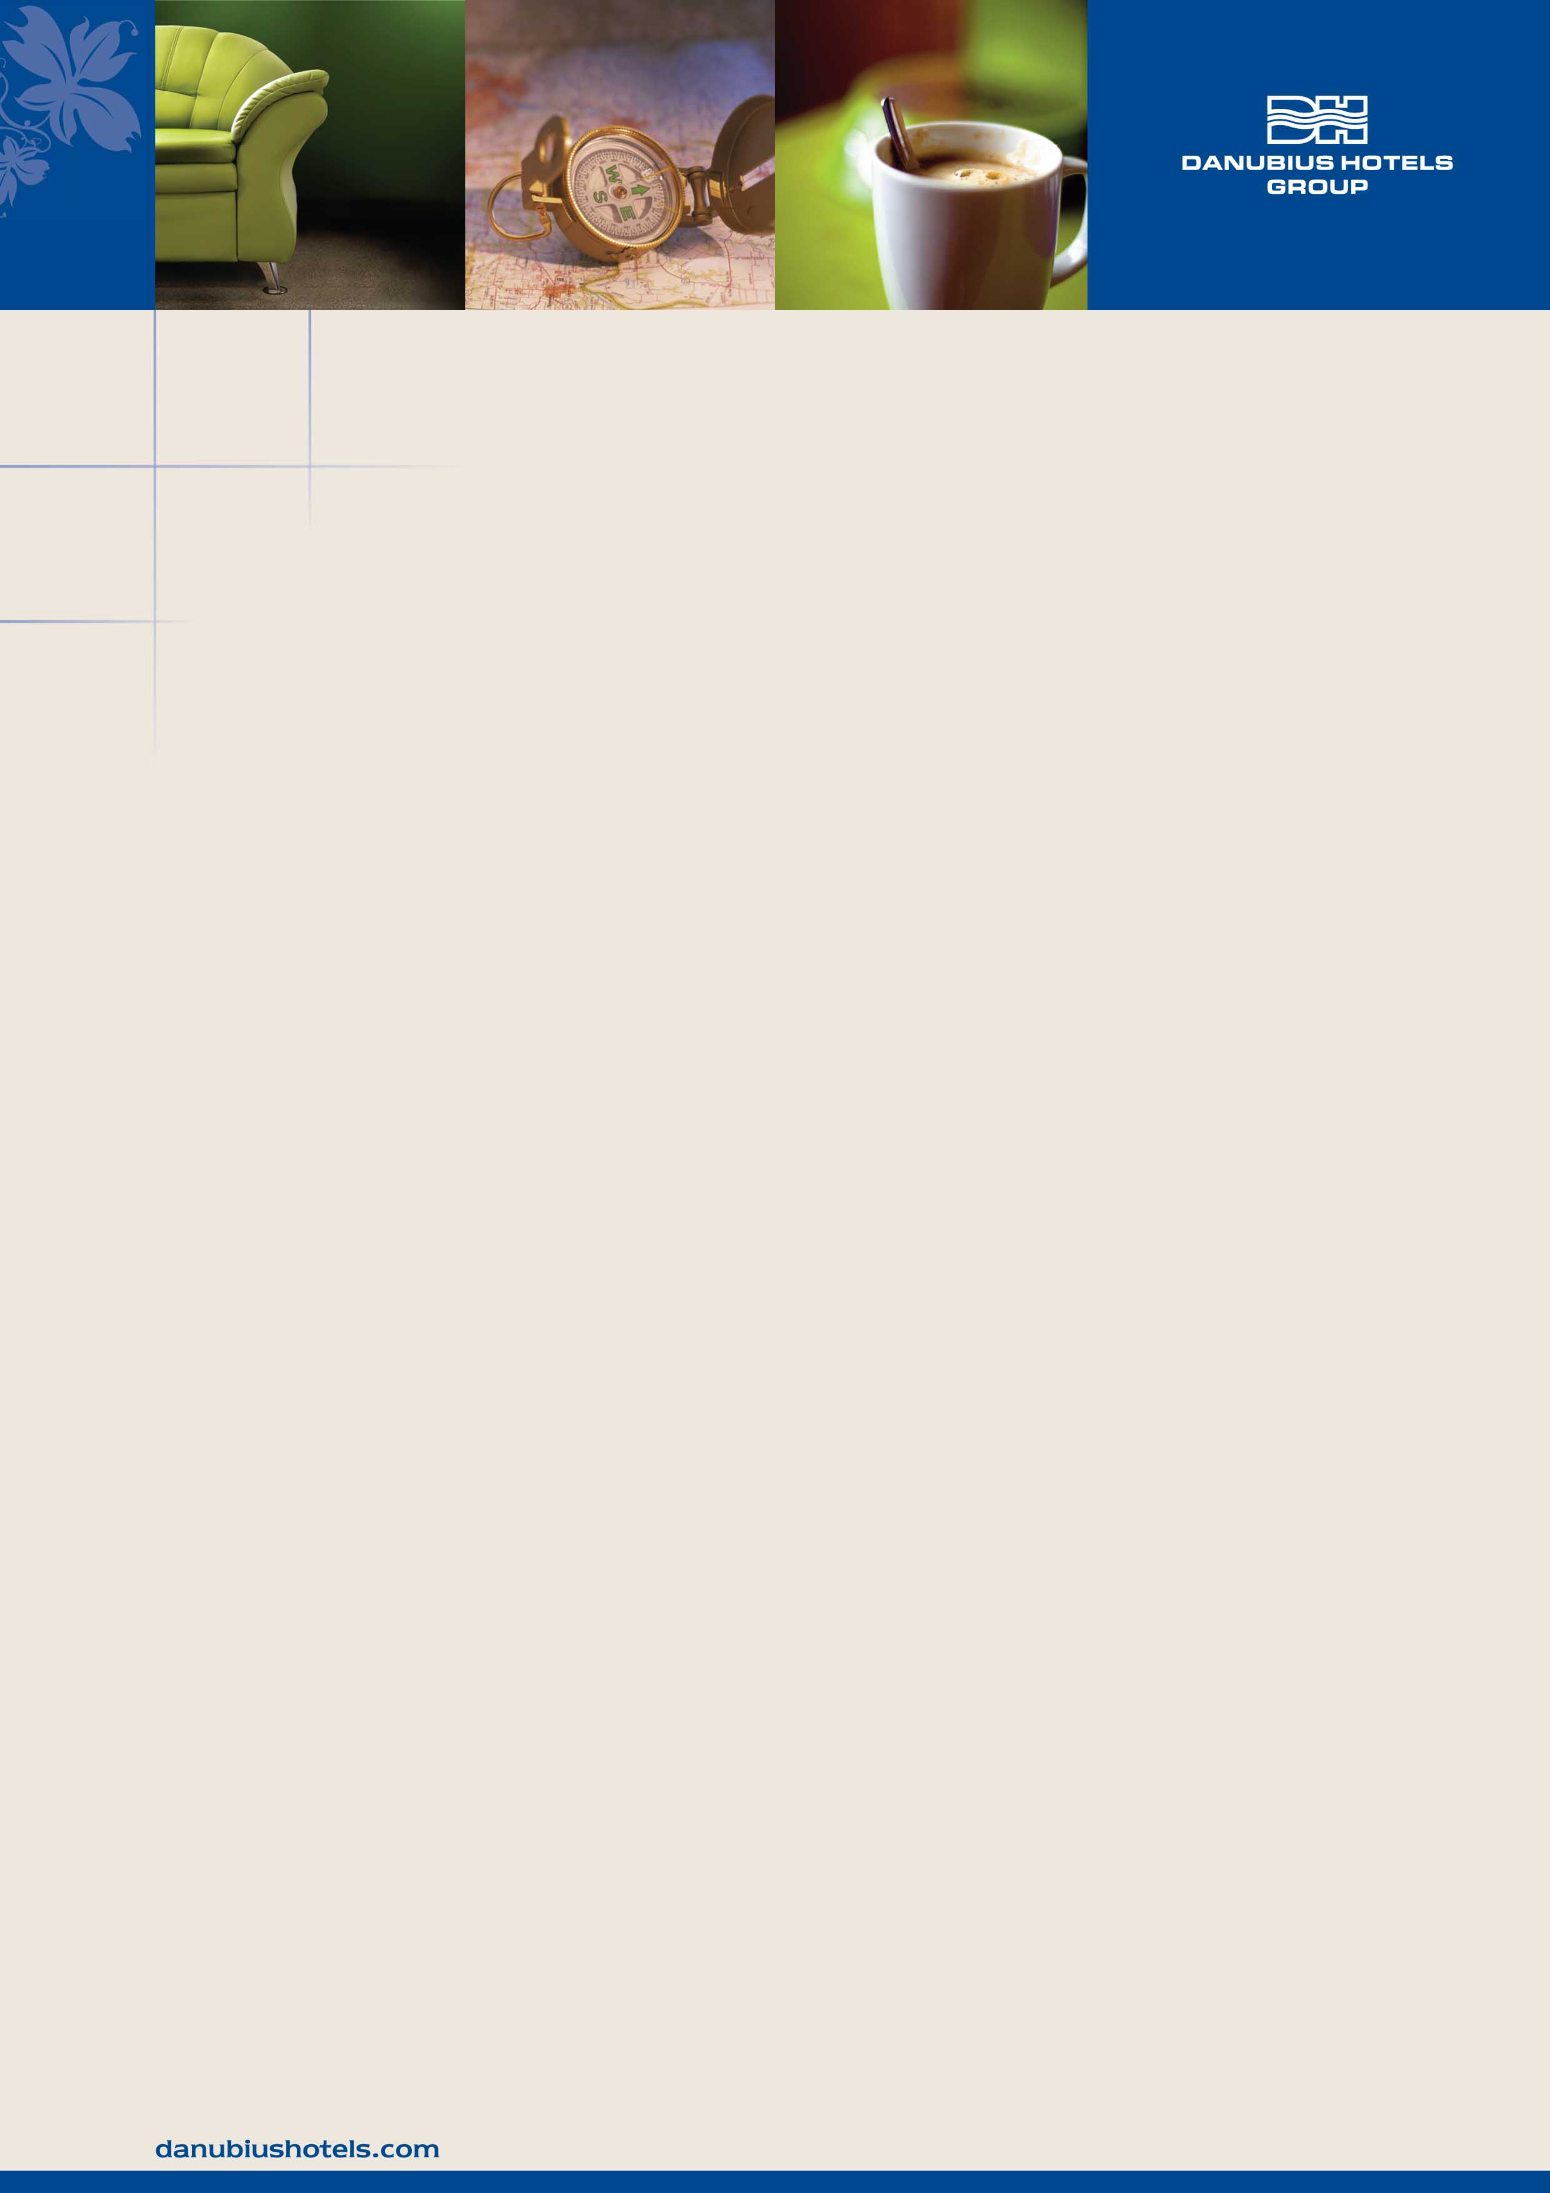

5th EOS Topical Meeting on
Terahertz Science & Technology (TST 2016)
8th May 2016 – 12th May 2016

ACCOMMODATION FORM

Our hotel provides discounted rates for the participants of 5th EOS TST 2016 Meeting.
Please fill in this accommodation form and send it back to the hotel reservation department.

Hotel Palatinus City Center***^{superior}

Contact: Mrs Adrienn FEKETE
pecs.reservation@danubiushotels.com ; Tel/Fax: +36 72 889 462

Name of the Guest(s)
Company name
Company address
Contact /phone, mail

 | Price  room/night | Check-in | Check-out | Number of rooms
Standard single room | 58 EUR
Standard double room | 68 EUR

Room rate includes the accommodation with rich buffet-breakfast, use of sauna, free WiFi
and VAT.
Local tax is extra: 400 HUF/person/night (ca. 1,3 EUR/person/night)

RESERVATION AND PAYMENT INFORMATION
Cancellation deadline: 14 days prior to arrival (Penalty fee: 1 night accommodation)
A credit card number is required to confirm and guarantee your reservation. Your credit card will be charged in advance.
Please be informed that the check-in time is 14:00 and the check-out time is 10:00.

Credit card details –
Card holder’s name
CC number
Exp. date

PARKING FACILITY
Palatinus garage - 6 EUR/car/24 hours ; Entrance of the garage: Mária street 2.

For more information about our hotel visit our website: www.danubiushotels.com/palatinus

